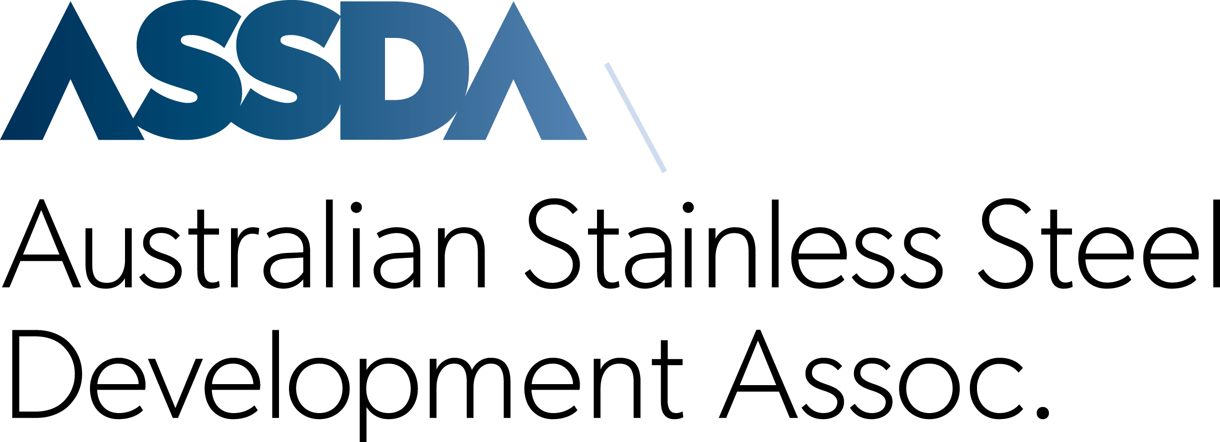

ASSDA FABRICATOR PROJECT OF THE YEAR 2026
SUBMISSION FORM

IMPORTANT
Project entries are welcome from (financial) Members of ASSDA. Please refer to the Rules of Entry at the end of this document.

Please provide as much information as possible to support your entry. Project submissions are due Friday 18 September 2026, and must be emailed to:
awards@assda.asn.au

ASSDA Member Organisation

INSERT

Contact Name

INSERT

Position

INSERT

Email

INSERT

Phone

INSERT

Postal Address

INSERT

Name of Project

INSERT

Awards category (please select)

Architecture, Building and Construction

Food, Beverage and Pharmaceutical

Process Industries

Small Project, Big Impact (projects valued under AU$1 million)

Client

INSERT

Location

INSERT

Start and completion dates

INSERT

Quantity of stainless steel used

INSERT

Stainless steel grade/s and surface finish used

INSERT

Materials suppliers

INSERT

Project summary
Scope of work, application summary, why stainless steel was used and its benefits, including if stainless steel replaced another material in the original specification.

INSERT

Criteria 1: Excellence
Please highlight any exceptional aspects of the project; how does the project demonstrate excellence in terms of its design, fabrication, and installation? How does it stand out in terms of achievement and impact?

INSERT

Criteria 2: Innovation
Describe the creative and innovative elements of your project that demonstrate originality and advancement in the industry, i.e., new technologies and fabrication techniques, unique application, etc.

INSERT
Criteria 3: Quality
Describe how your project emphasised productivity and customer service (examples are encouraged). How did you ensure high-quality standards were met throughout the project? Please include information on any welding procedures used, testing methods, and quality control measures implemented to maintain fabrication excellence.

INSERT
Criteria 4: Sustainability and Environmental Considerations
Does your project address environmental considerations such as energy efficiency, waste reduction, etc.? Were sustainability issues addressed by you or the client? How did stainless steel support those criteria? What has your organisation and/or project done to minimise your carbon footprint and promote sustainability?

INSERT

Motivation for Award

INSERT
Additional information

INSERT
Please attach at least one high-resolution project photo and provide any necessary photo acknowledgements below.

INSERT

You may also include supporting media such as project media releases, video reels, time-lapse videos, and other relevant content to enhance your project submission. Please list these below.

INSERT

By submitting your project, you acknowledge and adhere to the Rules of Entry below.

SIGNATURE ___________________________________

DATE ___________________________________

ASSDA FABRICATOR PROJECT OF THE YEAR 2026
RULES OF ENTRY
- Confidentiality: All project entries are treated in the strictest confidence.
- Eligibility: Entries are welcome from Members of ASSDA in good standing, i.e., you must be a financial Member of the Association to qualify.
- Submission deadline: All entries must be submitted and received by ASSDA no later than Friday 18 September 2026. Submissions should be emailed to awards@assda.asn.au. Entrants will receive an email acknowledgement of their submission.
- Entry requirements: Each entry must be accompanied by a fully completed submission form illustrated with high-resolution photos. Additional materials such as project media releases, time-lapse videos, etc., may be included to enhance the project submission.
- Single design or project: Each submission is limited to a single design or project and must be done with prior approval from all principal parties involved.
- Joint applications: In the case of a collaborative or joint effort, ASSDA Members may submit a project as a joint application with another eligible ASSDA Member (who complies with point number 2).
- Multiple submissions: ASSDA Members are welcome to submit more than one project submission for consideration across multiple categories. However, you cannot re-submit projects that have previously won, been nominated, or been considered for an ASSDA Award.
- Permission for publicity: By entering the awards, participants grant ASSDA permission to use the entries for publicity purposes, which may include, but is not limited to, promotion of the project entries, media releases, social media posts, and website features. Entrants are responsible for ensuring that all relevant parties involved in the project (e.g. clients, collaborators, etc.) are aware of the entry and have granted permission for the project to be publicly shared.

- Impartial judging: Award winners will be determined by a judging panel comprising the ASSDA General Manager and appointed industry consultants. Projects are judged based on the criteria provided:
  - Excellence: Exceptional work, concepts, and execution.
  - Innovation: Creativity, originality, and advancement.
  - Quality: High standards of workmanship, including weld procedures and quality control, as well as productivity and customer satisfaction.
  - Sustainability and Environmental Considerations: Minimising your carbon footprint through the life of the product.
The judges’ decision is final, and no correspondence will be entered into.

- Award announcement: The winners of each award category will be announced at the PacRim Stainless 2026 Gala Dinner, scheduled for Wednesday 21 October 2026, 6.30pm – 11.00pm. The event will be held at Glasshouse, The Island Gold Coast, 3128 Surfers Blvd, Surfers Paradise, Queensland, 4217, Australia.

