Consumer and Community Involvement Seminar Series:

True Co-Design in Health and Medical Research
This is an essential webinar for anyone who is thinking about planning greater. This workshop will include the perspectives of a consumer and researcher with advice for researchers planning towards the co-design of their future research project with consumers.

When: Thursday 29 September 2022, 10am – 11am

Where: Zoom – please register below for zoom link

Register to attend via this link: True co-design in health and medical research

Our Presenters

Jessica Taylor – Consumer experience of co-designing health research
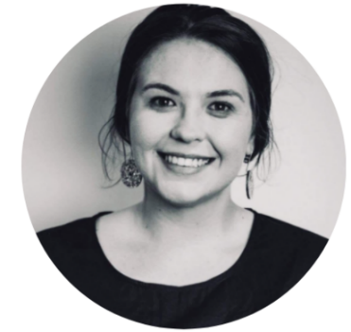
Jessica Taylor is an experienced Director, Chief Executive Officer and advisor who has worked in a range of organisations in commercial, public and not-for-profit sectors. Jessica has led peak bodies throughout her career. She is a consumer engagement specialist, expert in governance and an experienced spokesperson. Jessica consults and mentors several researchers, organisations and companies across Australia regarding their grant applications, consumer engagement strategy, business strategy and architecture, governance and engagement.
Jessica serves as a reviewer for MRFF grant schemes and is the President of QENDO (Peak advocacy organisation for endometriosis).

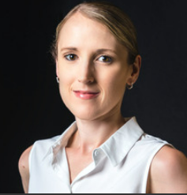
Dr Sally Mortlock – Consumer engagement journey and impact
Dr Sally Mortlock is the lead computational biologist within the Genomics of Reproduction Disorders group at the Institute for Molecular Bioscience. She leads analysis of the largest molecular datasets for endometrium for both Australian and international endometriosis cohorts. Her studies have expanded knowledge of the genetic and epigenetic regulation in endometrium generating important data resources to identify gene targets regulating female reproductive traits and diseases.
Sally has co-lead projects and grant applications with strong consumer involvement and continues to work alongside consumers and their representatives to advance endometriosis research.

Jo Maxwell – The Co-design continuum, working towards Co-creation
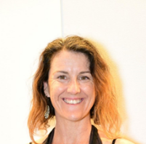
Jo is the Faculty of Medicine Principal Project Officer, Consumer Engagement and Indigenous Research Strategy. She provides support for the training, implementation, and evaluation of consumer engagement initiatives in health research.
Jo comes to UQ from working extensively with not-for-profit organisations in health, disability, and aged care. Previously she has coordinated the involvement of consumers in the development of clinical guidelines and is also a lived experience representative on a national mental health service program.

